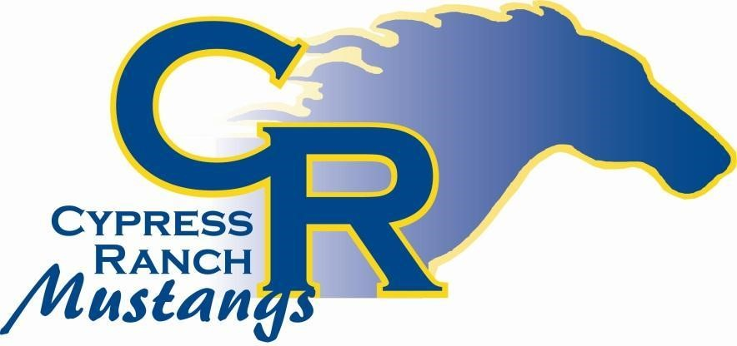
CYPRESS RANCH FFA BOOSTER CLUB
2023-2024 MEMBERSHIP FORM
The Cypress Ranch FFA Booster Club NEEDS YOUR PARTICIPATION AND SUPPORT! If you have a student who will participate in any of the Cypress Ranch FFA Chapter activities, it is important for you to join the Cypress Ranch FFA Booster Club today! As an active member of the Booster Club, you will be on the forefront of communication! You will receive a detailed monthly e-mail of current events and volunteer opportunities supporting the chapter. FFA activities heighten the overall experience of every FFA student and we look forward to working together to help Cypress Ranch FFA students excel in all of their endeavors.
You can now pay by Venmo...Cy Ranch FFA Booster Club (CyRanch-FFABoosterClub)
BE A PART OF THE MUSTANG EXPERIENCE, JOIN TODAY!
THANK YOU FOR YOUR SUPPORT!

ANNUAL BOOSTER CLUB MEMBERSHIP DUES ARE $30.00 PER FAMILY
Please make checks payable to Cypress Ranch FFA Booster Club
First Parent/Guardian Name: _________________________________________________________________
Address:_________________________________________________________________________________ Cell #: ________________________ Email Address:_____________________________________________
Second Parent/Guardian Name: _______________________________________________________________ Address (if different): _______________________________________________________________________ Cell #: _______________________ Email Address: ________________________________________________
Student Name(s): ________________________ Grade: _______________
_________________________ Grade: _______________
-----------------------------------------------------------------------------------------------------------------------------------------------
ITEMS | QTY | PRICE/UNIT | TOTAL
Booster Club Membership Dues |  | $ 30.00
CyRanch FFA Hats |  | $30.00
Cypress Ranch FFA Car decals |  | $10.00
TOTAL
Amount Received: _____________ Cash, Check Number, Venmo ___________ Date:_______________
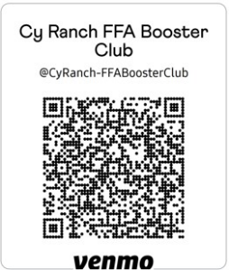
PLEASE NOTE: Cypress Ranch FFA Booster Club Membership and Dues are separate from the Cypress Ranch FFA membership dues for students.
The Cypress Ranch FFA Booster Club supports the members of the Cypress Ranch FFA Chapter. Membership dues for the Chapter are collected by the
FFA Advisor/Instructor and are remitted to the National FFA Organization on behalf of the students.

